Airports Authority of India

Press Release

Signing of MoU between Airport Authority of India (AAI)
and
Artificial Limbs Manufacturing Corporation of India (ALIMCO)

New Delhi, 4th September, 2017: As part of Corporate Social Responsibility, AAI has taken several steps to sustain and empower under-privileged communities near its airports and provide necessary help in socio-economic development of the region. AAI is working in health, sanitation, Paper Recycling, Rural Sports Education & Skill Development.

One of the recent initiatives have been signing of MoU between AAI and ALIMCO on 4th September 2017 at Rajiv Gandhi Bhavan, Safdarjung Airport, New Delhi and AAI for Rs.669.00 lakhs for conducting Cochlear Implant surgeries for under-privileged children on PAN India basis. The MoU was signed in the august presence of Shri Guruprasad Mohapatra, I.A.S., Chairman, AAI and Shri D.R. Sarin, CMD, ALIMCO and senior executives of both the organisations.

As per estimate more than 10,000 children in India are born with congenital hearing loss and require cochlear implant. This major CSR initiative of AAI will help the children to completely overcome their hearing disability, thereby enabling them to hear and speak coherently and making them fully independent to lead a normal and productive life. This effort will not only bring these underprivileged children to the mainstream of life but will also contribute to national economy.

AAI will stay committed for socio-economic development and bringing change in the life of under-privileged communities evolving them to the party of the sustainable development.
Issued by Public RelationsDepartment
For details please contact:
GM (PR), 9811521881, 011-24622787
Press Release No. 28/2017-18

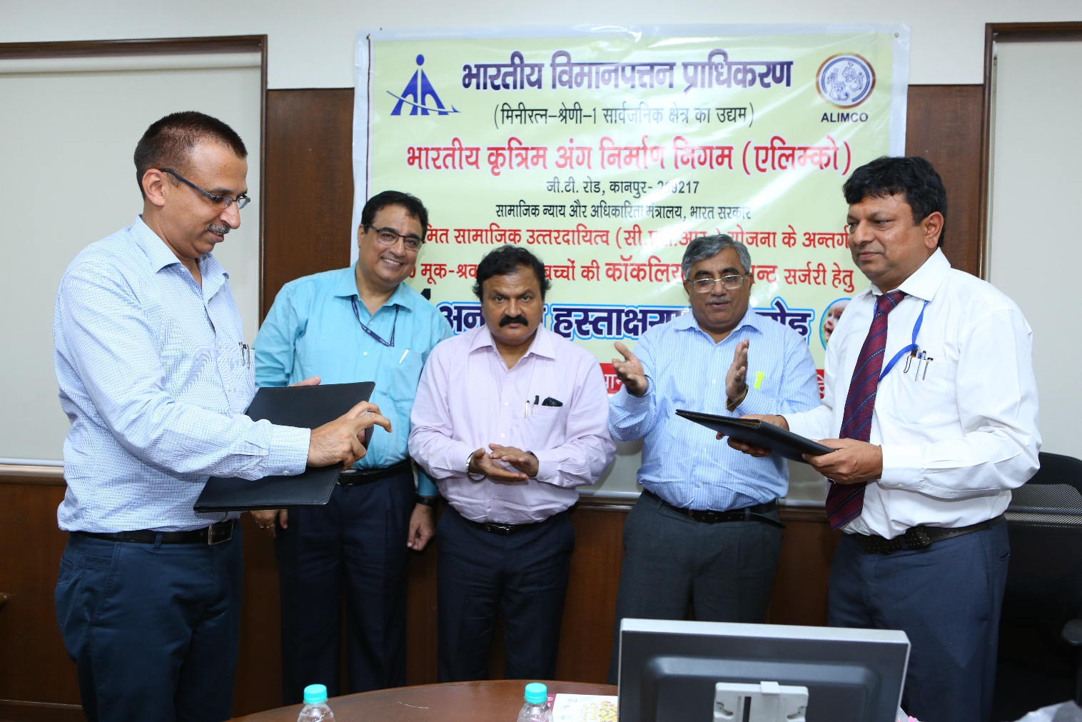

Shri Sanjeev Jindal, General Manager (CSR), Airports Authority of India (AAI) exchanging MoU with Shri D.R.Sarin, Chairman and Managing Director, Artificial Limbs Manufacturing Corporation of India (ALIMCO) in presence of Dr. Guruprasad Mohapatra, IAS, Chairman, AAI and Shri Sudhir Raheja, Member (Planning), AAI for conducting Cochlear Implant surgeries for under-privileged children on Pan-India basis under CSR Activities on 4th September, 2017 at Rajiv Gandhi Bhawan, New Delhi.

