Airports Authority of India
Press Release

Kalyanmayee-Airports Authority of India Women Welfare Association works towards the healthcare, education, environment and Swachh Bharat initiatives

New Delhi, 29th August 2017: Kalyanmayee, Airports Authority of India Women Welfare Association (AAIWWA) works towards the healthcare, education, environment and Swachh Bharat initiatives to help the underprivileged and needy.

Kalyanmayee, under the able leadership of Mrs. Anjali Mohapatra, All India President, organized a Cervical Cancer detection camps. “Mahila Swaasthya Jaanch Shivirs” at Kanakdurga basti at RK Puram, New Delhi recently with support of NGOs like AOGIN India and CANSupport to examine women for reproductive health, especially for Cervical Cancer. Similar camps were also organized in the past at Swami Vivekanand Basti Channkyapuri and Seelampur. The target group for screening was women aged between 30-60 years, which is the most appropriate age for Cancer screening.

The main objectives of these camps were:
- To improve awareness about Cervical Cancer, the most common Cancer in India
- To improve awareness about general good health-seeking behavior, nutrition, etc.
- To carry out screening for pre-Cancerous and Cancerous Cervical lesions by Pap Smear Test.
- To treat minor Gynaecological complaints
- To facilitate hospital visit for women detected to be screen positive and complete treatment as required.

The exclusivity of these camps are not just screening but to improve awareness about general good health-seeking behavior, nutrition, Cervical and Breast Cancer, the two most common Cancers in India. Helping women to learn techniques of self-examination of breasts and also further teach other women in family and check their daughters too. The camps also tested them for Anemia and other Gynecological complaints. Further, Kalyanmayee facilitates the treatment of the women in AIIMS and GTB Hospital, detected to be screen positive as suggested by the doctors’ team.

In these three camps 132 women were examined and 22 called for further treatment in GTB Hospital and AIIMS and 14 have been found positive. Kalyanmayee is also following up with CANSupport to ensure that those who need further treatment should visit hospital for further treatment. Kalyamayee is also planning to take this project to other cities across the country as well as in other parts of Delhi.

Kalyamayee is also replicating this project to 11 cities across the country as well as in other parts of Delhi for next three consecutive years.
____________________________________________________________________________
Issued by Public RelationsDepartment
For details please contact:
GM (PR), 9811521881, 011-24622787
Press Release No. 27/2017-18

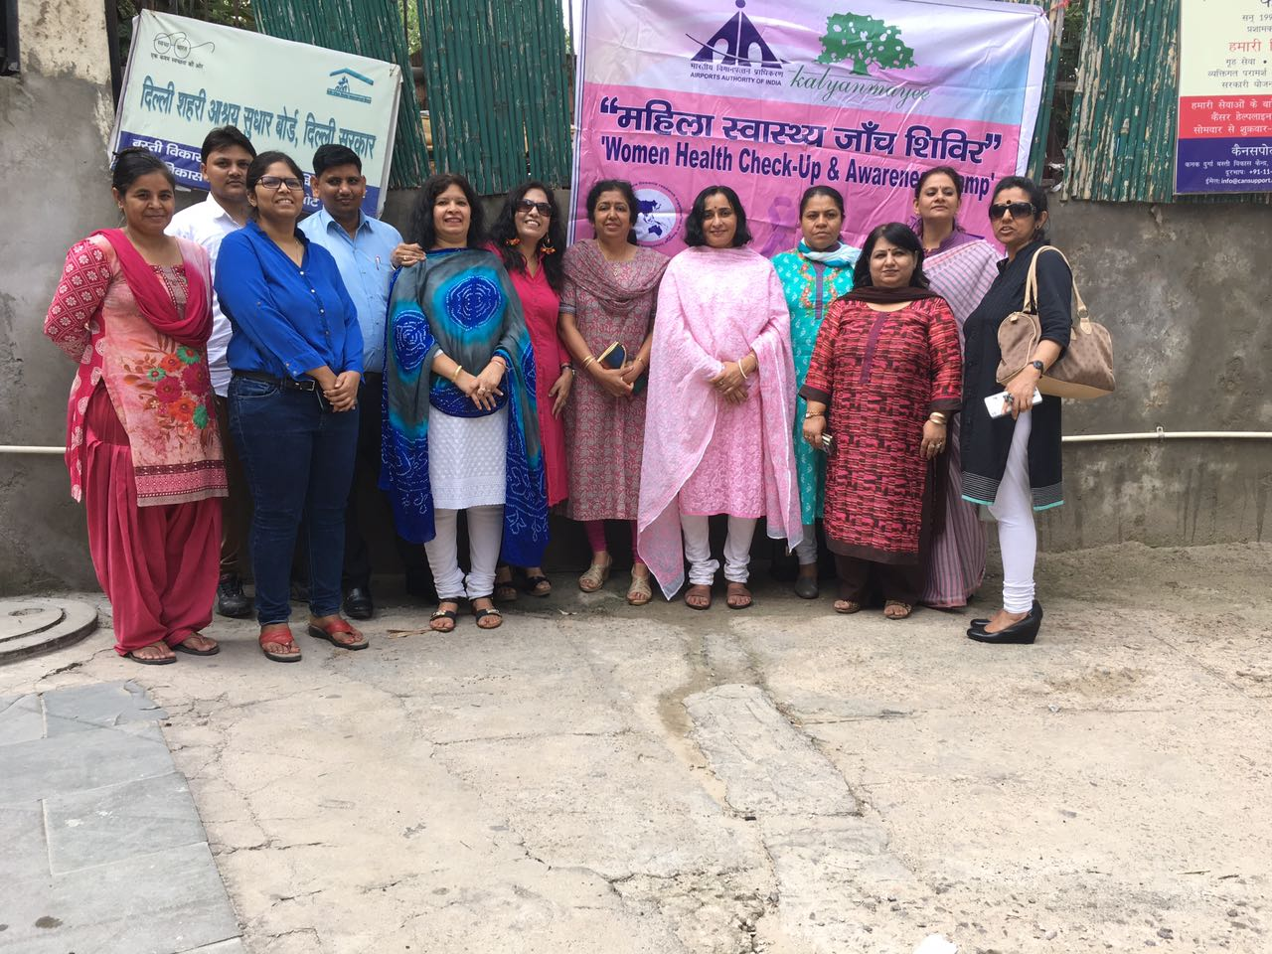
Kalyanmayee-Airports Authority of India Women Welfare Association organizing a cervical cancer detection camps. “Mahila Swaasthya Jaanch Shivirs” at Kanakdurga basti at RK Puram, New Delhi

