AIRPORTS AUTHORITY OF INDIA

PRESS RELEASE

AAI celebrates 71st Independence Day

New Delhi, 16th August, 2017:Airports Authority of India celebrated 71stIndependence Day at New ATS Complex, IGI Airport with fervour and joy. The celebration started with flag hoistingby Dr Guruprasad Mohapatra, Chairman, AAI. While addressing the officials, Dr.Mohapatra said that “the progressive initiatives undertaken by the Government of India have led AAI to increase and improve its current infrastructure by developing airports that are modern and efficient to facilitate easier movement of travelers.” On this occasion, students of Kendriya Vidyalaya, AAI, Rangpuri gave cultural performances highlighting the rich and diverse cultural heritage of the country.

AAI also launched itsnew website, to cater increased requirements and to provide a better platform for the stakeholders for gathering information. A tree plantation drive was also organized at new ATS complex and upcoming new building of Indian Aviation Academy (IAA) at Vasant Kunj where Chairman and other senior officials of AAI planted saplings.Simultaneously, all the Regional Headquarters of AAI and Airports celebrated Independence Day with full enthusiasm.

__________________________________________________________________
Issued by Public Relations Department
For details please contact: GM (PR),
9811521881, 011-24622787
Press Release No. 22/ 2017-18

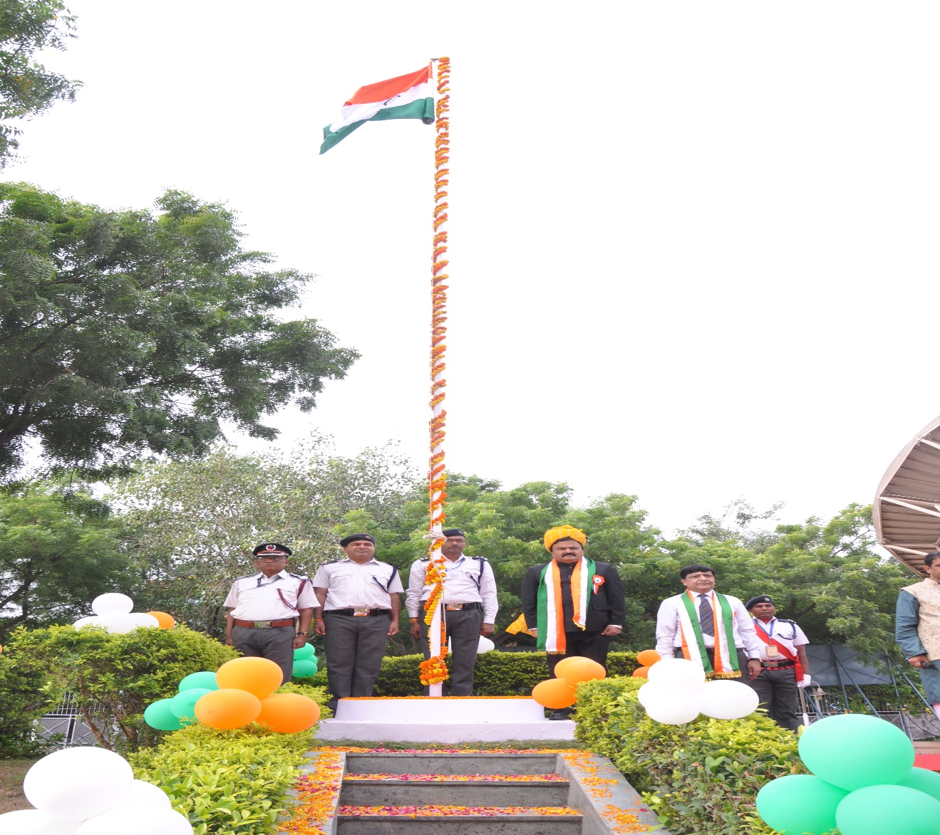

Dr.Guruprasad Mohapatra, Chairman, Airports Authority of India hoisting the flag at New ATS Building, IGI Airport on the occasion of 71st Independence Day

