AIRPORTS AUTHORITY OF INDIA
Press Brief
Upgraded Jammu Airport inaugurated: Augmenting Infrastructure
for Enhancing Connectivity
Jammu, 17th August 2017: The upgraded passenger Terminal Building of Jammu Airport, Jammu was inaugurated by Ms. Mehbooba Mufti, Chief Minister of Jammu & Kashmir and Shri P. Ashok Gajapathi Raju, Union Minister for Civil Aviation. Shri Jayant Sinha, Union Minister of State for Civil Aviation; Dr. Jitendra Singh, Union Minister of State for Development of North Eastern Region, PMO, Personnel, Public Grievances and Pensions, Atomic Energy and Space; Dr. Nirmal Kumar Singh, Deputy Chief Minister of Jammu & Kashmir; Shri Kavinder Gupta, Speaker of J&K Legislative Assembly; Shri Jugal Kishore Sharma, Member of Parliament (Lok Sabha) and Shri Shamsher Singh Manhas, Member of Parliament (Rajya Sabha) along with Dr. Guruprasad Mohapatra, Chairman, Airports Authority of India were the other esteemed guests who attended the inauguration ceremony.
Jammu is the gateway city for the State of Jammu & Kashmir and the winter capital of the State, is also popularly known as the ‘City of Temples.’ Bestowed with a rich heritage and cultural legacy, Jammu has promising tourism potential. The city is famous for religious tourism and the holy shrine of ‘Mata Vaishno Devi’ is 46 kms. from the city.
Jammu Airport belongs to the Indian Air Force, Ministry of Defence and AAI maintains a Civil Enclave for civil aircraft operations. During the year 2016-17, passenger traffic movement at Jammu Airport reached 1.16 million and the passenger growth rate has touched 29 per cent in the first quarter of 2017-18. To cope with the increasing passenger growth and demand, expansion & upgradation of existing Terminal Building of Jammu Airport has been completed. The area of the Terminal Building is expanded from 6700 sq. mtrs. to 14,500 sq. mtrs. with an upgraded peak hour handling capacity of 720 passengers at a time, an increase from the existing 360 peak hour passengers.
The upgraded passenger Terminal Building of Jammu Airport is a glass and steel structure and is equipped with Passenger facilities and amenities like CUTE-complied Check-in Counters, Common Use Self-Service (CUSS) kiosk for Check-in, Central Air-Conditioning, two Arrival Conveyer belts, Escalators and Glass Elevators, Flight Information Display System, PA system with comfortable Seating capacity.
For safety and security of passengers, Terminal Building is equipped with Fire Fighting and Fire Alarm System, CCTV and Baggage Scanners etc. There is a provision for installation of three Passenger Boarding Bridges with Advanced Visual Docking Guidance System (AVDGS) for the Terminal which would increase operational efficiency besides convenience to passengers.
While inaugurating the upgraded Terminal Building, Shri P. Ashok Gajapathi Raju, Union Minister of Civil Aviation said, “We believe in augmenting infrastructure of our airports to enhance connectivity. With the upgraded Jammu Airport, we would be better prepared to give improved services to air travelers visiting this city of temples.”
Appreciating the upgraded Terminal Building of Jammu Airport, Ms. Mehbooba Mufti, Chief Minister, Jammu and Kashmir said, “We have been witnessing promising growth in number of air travelers to and from Jammu. The upgraded Terminal of Jammu Airport is in line to enhance capacity and will contribute to the economic growth of Jammu – the gateway to the State.”
The upgraded passenger Terminal Building of Jammu Airport is equipped with Green features like: double insulated roofing system, rainwater harvesting, 200 KLD sewage treatment plant (soil-based technology), reuse of treated water for horticulture and air conditioning purposes, use of fly ash bricks, low heat gain glazing, low VOC (Volatile Organic Compound) paints, LED lighting, energy efficient chillers, VFDs (Variable Frequency Drive) for high Capacity Motors.
Issued by Airport Director, Jammu Airport
For details please contact at:
09419180970, 0191-2437843
Press Release No. 23/2017-18
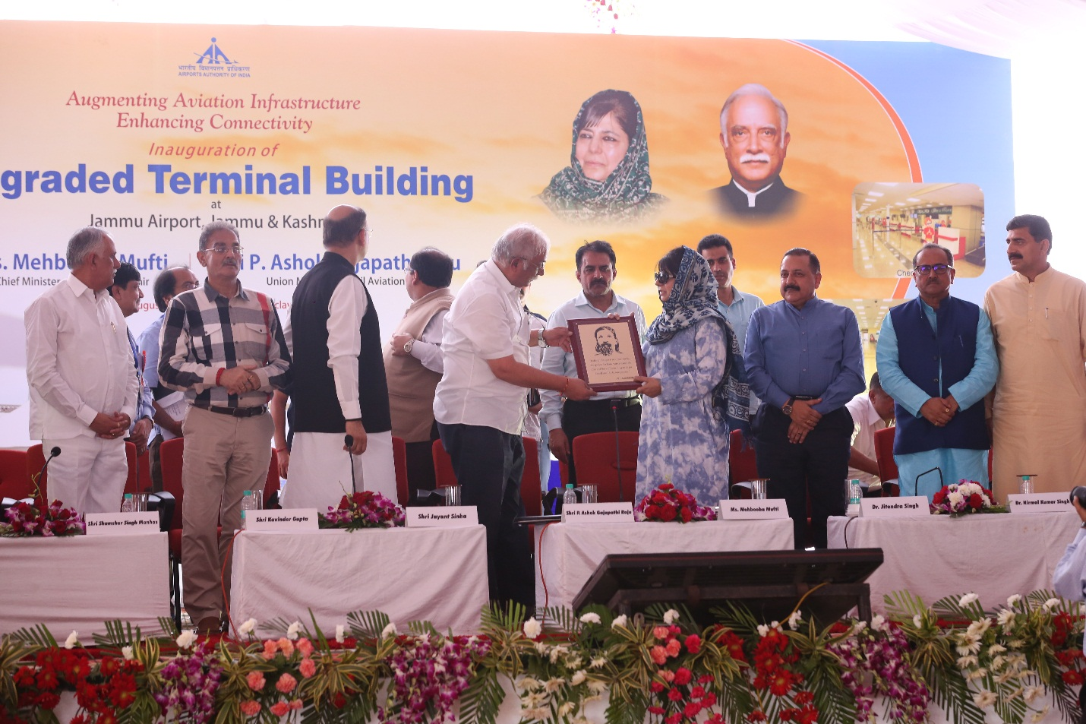
Shri P. Ashok Gajapathi Raju, Union Minister of Civil Aviation presenting memento to Ms. Mehbooba Mufti, Chief Minister of Jammu & Kashmir on the occasion of inauguration of the upgraded Terminal Building of Jammu Airport, Jammu.

