AIRPORTS AUTHORITY OF INDIA

PRESS RELEASE

Airports Authority of India celebrated "Library Week" from 04th -10th August, 2017

New Delhi, 11th August, 2017: Airports Authority of India (AAI) celebrated "Library Week” from 04thto10thAugust, 2017 at Corporate Headquarters, Rajiv Gandhi Bhawan, Safdarjung Airport, New Delhi. During the inaugural ceremony, the lecture was delivered by Dr. Harish Arora, Professor, University of Delhi, on the theme "Our cultural heritage of the library" in the presence of Senior Officers and employees of Ministry of Civil Aviation and AAI. During the Library Week, discussions, quiz and slogan writing competitions and a book exhibition were also organized for the employees of Airports Authority of India.

During the closing ceremony, Shri Anuj Aggarwal, Member (HR), AAI distributed the prizes to the winners and advised all employees to utilize the library to the fullest.
Issued by Public Relations Department
For details please contact: GM (PR),
9811521881, 011-24622787
Press Release No. 21/ 2017-18

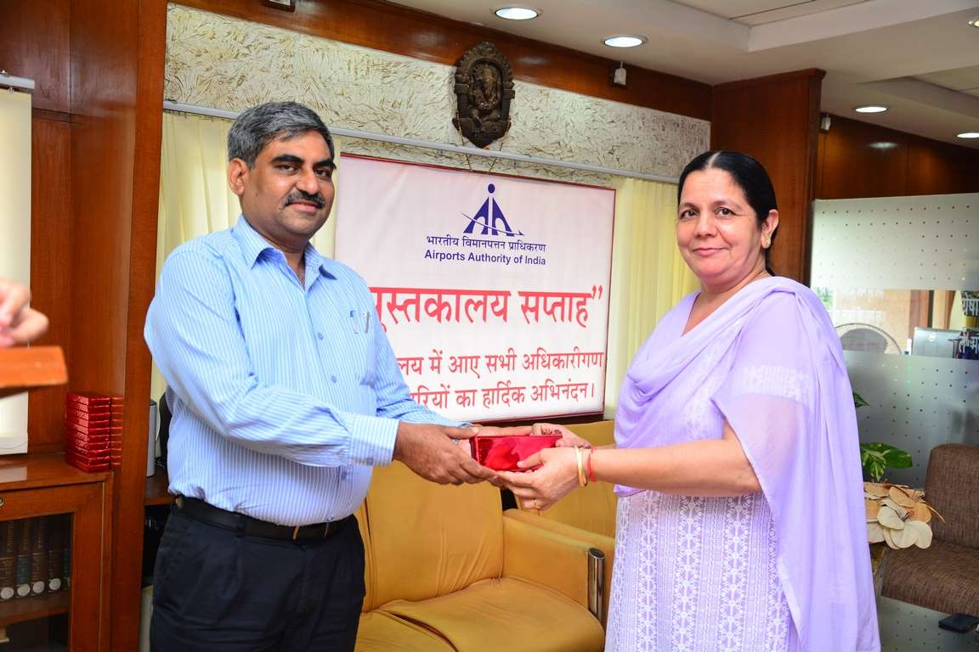

Shri Anuj Aggarwal, Member (HR), AAI distributing prize to the winner participant.

